Congratulations!
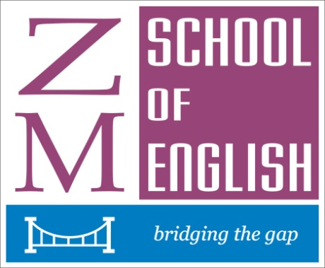
ZMS Prize Winners – 2012
AWARDS, TEACHERS’ CERTIFICATES AND DIPLOMAS
NAMES SUBJECT
Hajra Osman Licentiate Diploma in the Teaching of English to
Speakers of Other Languages
Kumala Wijeratne Licentiate Diploma in the Teaching of English to
Speakers of Other Languages

Aaysha Ifthikar Associate Recital Diploma

Usha Thevathas Certificate in Teaching of English to Intermediate Learners

Hajra Osman Reading from the Holy Qu’ran – Gold Award
Usha Thevathas Reading from Bhagavad Gita - Gold Award
Aanisha Sameen Prose Reading - Gold Award

SCHOLARSHIP AWARDS
Khaalisha Ilham
Tashya Fernando
Khadeeja Ilham
Nisara Rathnayake
Nihila Premakanthan
Naushara Packeer
Niluka Abyegunaratne

NAMES SUBJECT GRADE
S.D. Tashya Fernando Speech & Drama Grade One
Khadeeja Ilham Speech & Drama Grade Two
Niluka Bandara Abeygunaratne Speech & Drama Grade Six

Gehansa Wahalawatte Effective Communication Preparatory Grade
KavinashSrikanth Effective Communication Grade One

S D Tashya Fernando Prose Reading Primary Grade

Khaalisha Ilham Acting in Pairs Primary Grade
Khadeeja Ilham Acting in pairs Primary Grade

Naushara Packeer Reading from the Holy Qu’ran Grade Two
S D Tashya Fernando Reading from the Light of Asia Grade Two

Umayyah Osman Communication Skills Grade One
Kavinash Srikanth Communication Skills Grade One
Nihila Premakanthan Communication Skills Grade One
Rashmi Kumarasinha Communication Skills Grade Two
Khadeeja Ilham Communication Skills Grade Three
Jayasithu Hewavitharana Communication Skills Grade six
Niluka Bandara Abeygunaratne Communication Skills Grade Six
Ramith Fonseka Communication Skills Grade Seven

Kadeeja Kassim Spoken English Junior Preparatory
Ruwanpurage Dinil Sevinda Spoken English Junior Preparatory
M.K. Gayanaka Sethmina Spoken English Junior Preparatory
Isali Onethma Abeysinghe Spoken English Junior Preparatory
Chanara T. Gunaratne Spoken English Junior Preparatory
Salma Farveen Ghouse Spoken English Junior Preparatory
Gayathri Anandhakumar Spoken English Junior Preparatory
Ahamed Akmal Hamid Spoken English Junior Preparatory

Fathima Shazfa Sameem Spoken English Preparatory
T.M. Humaydh Raheem Spoken English Preparatory
Sandul Kumarasinha Spoken English Preparatory
Gehansa Kalhari Wahalawatte Spoken English Preparatory

Nishadi Hewamalika Spoken English Grade One
S.D. Tashya Fernando Spoken English Grade One
Thulana Vinnath Jayasekara Spoken English Grade One

Chamath K.Weerasinghe Spoken English Medial Grade

Saritha Goonathilaka Spoken English Grade Two
Senuka Munasinghe Spoken English Grade Two
Nihila Premakanthan Spoken English Grade Two
Nisara Chathurdhanee Rathnayake Spoken English Grade Two
Hesandi Antonette Hettiarachchi Spoken English Grade Two

Supuli Gunawardhana Spoken English Grade Four

Sanjaya Aluwihara Spoken English Grade Five
Dileka Munasinghe Spoken English Grade Five

Shamima Parveen Ghouse Spoken English Grade Seven

Niluka Abyegunaratne Spoken English Grade Nine

Yasindu Adikaram Creative Writing Grade One

Ramith Fonseka Creative writing Grade seven

Onadi Amarasena Written English Junior Preparatory

Chanara T.Gunaratne Written English Preparatory
Salma Farveen Ghouse Written English Preparatory
Kaushik Niranjankumar Written English Preparatory

Asmaa Osman Written English Grade One
S.D.Tashya Fernando Written English Grade One
Osani Kavithya Written English Grade One

Chamath Weerasinghe Written English Medial Grade

Nisara Chathurdhanee Written English Grade Two
Udistan Anandkumar Written English Grade Two
Shavindra Dhanuka Dayawansea Written English Grade Two
Nisara Chathurdhanee Rathnayake Written English Grade Two

Praveen Aluwihare Written English Grade Four
Naushara Packeer Written English Grade Four

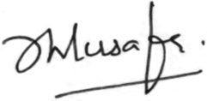
Congratulations to all of you! Well done.

Mrs. Zulfika Musafer

